Terahertz Multi-Quantum Well ATT Sources Based on AlGaN/GaN Material System
Sudip Chakraborty¹, Aritra Acharyya², Arindam Biswas³ and Anjan Kumar Kundu⁴
¹Department of Electrical Engineering, NSHM Knowledge Campus, Arrah, Shibtala, Durgapur, West Burdwan, West Bengal – 713212, India, email: sudip.0079@gmail.com
²Department of Electronics and Communication Engineering, Cooch Behar Government Engineering College, Harinchawra, Ghughumari, Cooch Behar, West Bengal – 736170, India, email: ari_besu@yahoo.co.in
³Institute of Radio Physics and Electronics, University of Calcutta, 92 APC Road, Kolkata – 700009, India, email: akkundu.rpe@caluniv.ac.in
⁴Centre for Organic Spin-tronics and Optoelectronics Devices (COSOD) and Mining Engineering Department, Kazi Nazrul University, Asansol, Burdwan, West Bengal – 713340, India, email: mailarindambiswas@yahoo.co.in

Abstract: Prospects of AlGaN/GaN heterostructure based multi-quantum well (MQW) avalanche transit time (ATT) source as high-power, low-noise terahertz (THz) wave generator have been documented in this chapter. A multi-stage-multi-iterative optimization (MSMIO) algorithm has been discussed for optimizing the design parameters of the MQW structure based THz sources based on AlGaN/GaN heterostructures. The large-signal and noise characteristics of optimized as well as un-optimized 1.0 THz MQW DDR structures are compared in order to verify the proficiency of the proposed algorithm; results are compared with simulation and experimental results of 1.0 THz oscillators based on other semiconductors.
Keywords: Avalanche transit time source, AlGaN, GaN, IMPATT, MQW, THz

1. Introduction
Impact avalanche transit time (IMPATT) sources based on some wide bandgap (WBG) semiconductors like SiC, GaN, diamond, etc. are recently attracting the interest of researchers for generating high-power terahertz (THz) wave with high DC to RF conversation efficiency [1-7]. One major problem with WBG IMPATT sources is higher noise level of those as compared to the IMPATT sources based on conventional narrowband (NBG) semiconductors like Si, GaAs, InP, etc [8]. Noise in IMPATT oscillators can be significantly reduced by using multi-quantum well (MQW) structures [9-11]. In conventional IMPATT sources, the efficiency reduces considerably at THz frequencies as a result of the saturation of ionization rate of electrons and holes as high electric fields; however, by using MQW structure in IMPATT diodes, the problem associated with the saturation of ionization rates can be eliminated [9-11].
In this chapter, primarily a multi-stage-multi-iterative optimization (MSMIO) algorithm has been discussed for optimizing the design parameters of THz MQW IMPATT sources; in this regard, MQW IMPATT diodes based on Al_{x}Ga_{1-x}N/GaN heterostructures have been taken into consideration; where x is the mole fraction of Al in Al_{x}Ga_{1-x}N. The optimization has been carried out subject to achieve favourable large-signal as well as avalanche noise characteristics of the source designed to operate at 1.0 THz. Six major parameters associated with the MQW structure, such as mole fraction (x) of Al in Al_{x}Ga_{1-x}N, thickness of Al_{x}Ga_{1-x}N layers (W_{b}), corresponding doping concentrations (N_{D(b)} for n-side and N_{A(b)} for p-side), thickness of GaN layers (W_{w}), corresponding doping concentrations (N_{D(w)} for n-side and N_{A(w)} for p-side) and bias current density (J₀) are optimized subject to attain highest DC to RF conversion efficiency as well as lowest noise measure of the source. The large-signal and noise characteristics of optimized as well as un-optimized MQW DDR structures are compared in order to verify the proficiency of the proposed algorithm; results are compared with simulation and experimental results of 1.0 THz oscillators reported earlier.
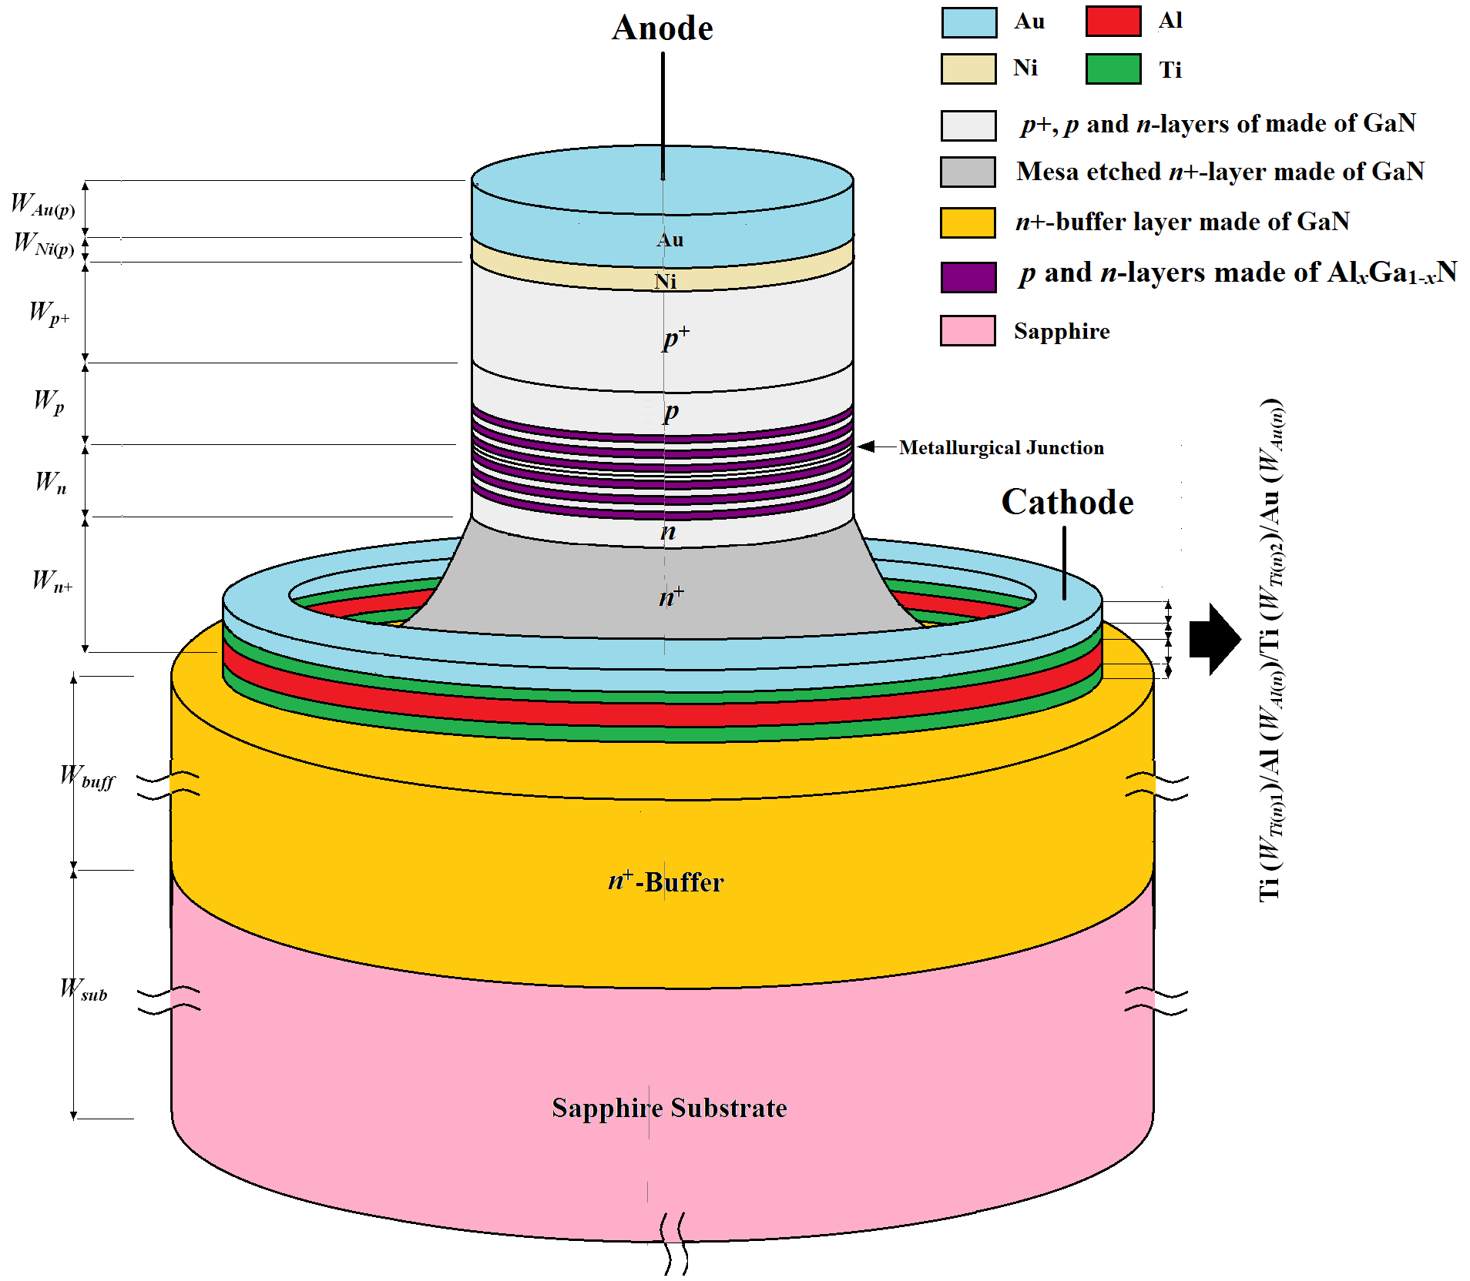
Fig. 1 Structure of the MQW DDR IMPATT diode based on Al_{x}Ga_{1-x}N/GaN heterostructures.

2. Structural Description
The 3-D view of the device structure having circular cross-section is shown in Fig. 1. The n⁺-n-p-p⁺ DDR structure having MQWs based on Al_{x}Ga_{1-x}N/GaN heterostructures, centred around the p-n junction, can be grown on c-plane (1000) sapphire (Al₂O₃) substrate by using either metalorganic vapour phase epitaxy (MOVPE) or metalorganic chemical vapour deposition (MOCVD) technique [12, 13]. However, for large-signal and noise simulations, the cross-section of the device have to be converted to rectangular by keeping the cross-sectional area fixed [14]; this conversion ensures the use of Cartesian coordinate system for the analysis instead of cylindrical coordinate system.
Table 1: Design parameters
 | Fixed Parameters |  |  |  |  |  |  |  |  | Optimizing Parameters
Structure | W_{n}  (nm) | W_{p}  (nm) | W_{n+}  (nm) | W_{p+}  (nm) | N_{D}  (×10²³ m⁻³) | N_{A}  (×10²³ m⁻³) | N_{n+}  (×10²⁴ m⁻³) | N_{p+}  (×10²⁴ m⁻³) | D_{j}  (µm) | x | W_{b}  (nm) | W_{w}  (nm) | N_{D(b)}  (×10²³ m⁻³) | N_{A(b)}  (×10²³ m⁻³) | J₀  (×10⁸ A m⁻²)
Un-Optimized | 185.0 | 185.0 | 300.0 | 200.0 | 7.00 | 6.80 | 2.00 | 2.00 | 5.00 | 0.1 – 0.6 | 5.0 | 5.0 | 10.00 | 10.00 | 45.00
Optimized | 185.0 | 185.0 | 300.0 | 200.0 | 7.00 | 6.80 | 2.00 | 2.00 | 5.00 | 0.43 | 4.15 | 4.20 | 11.50 | 12.30 | 42.44

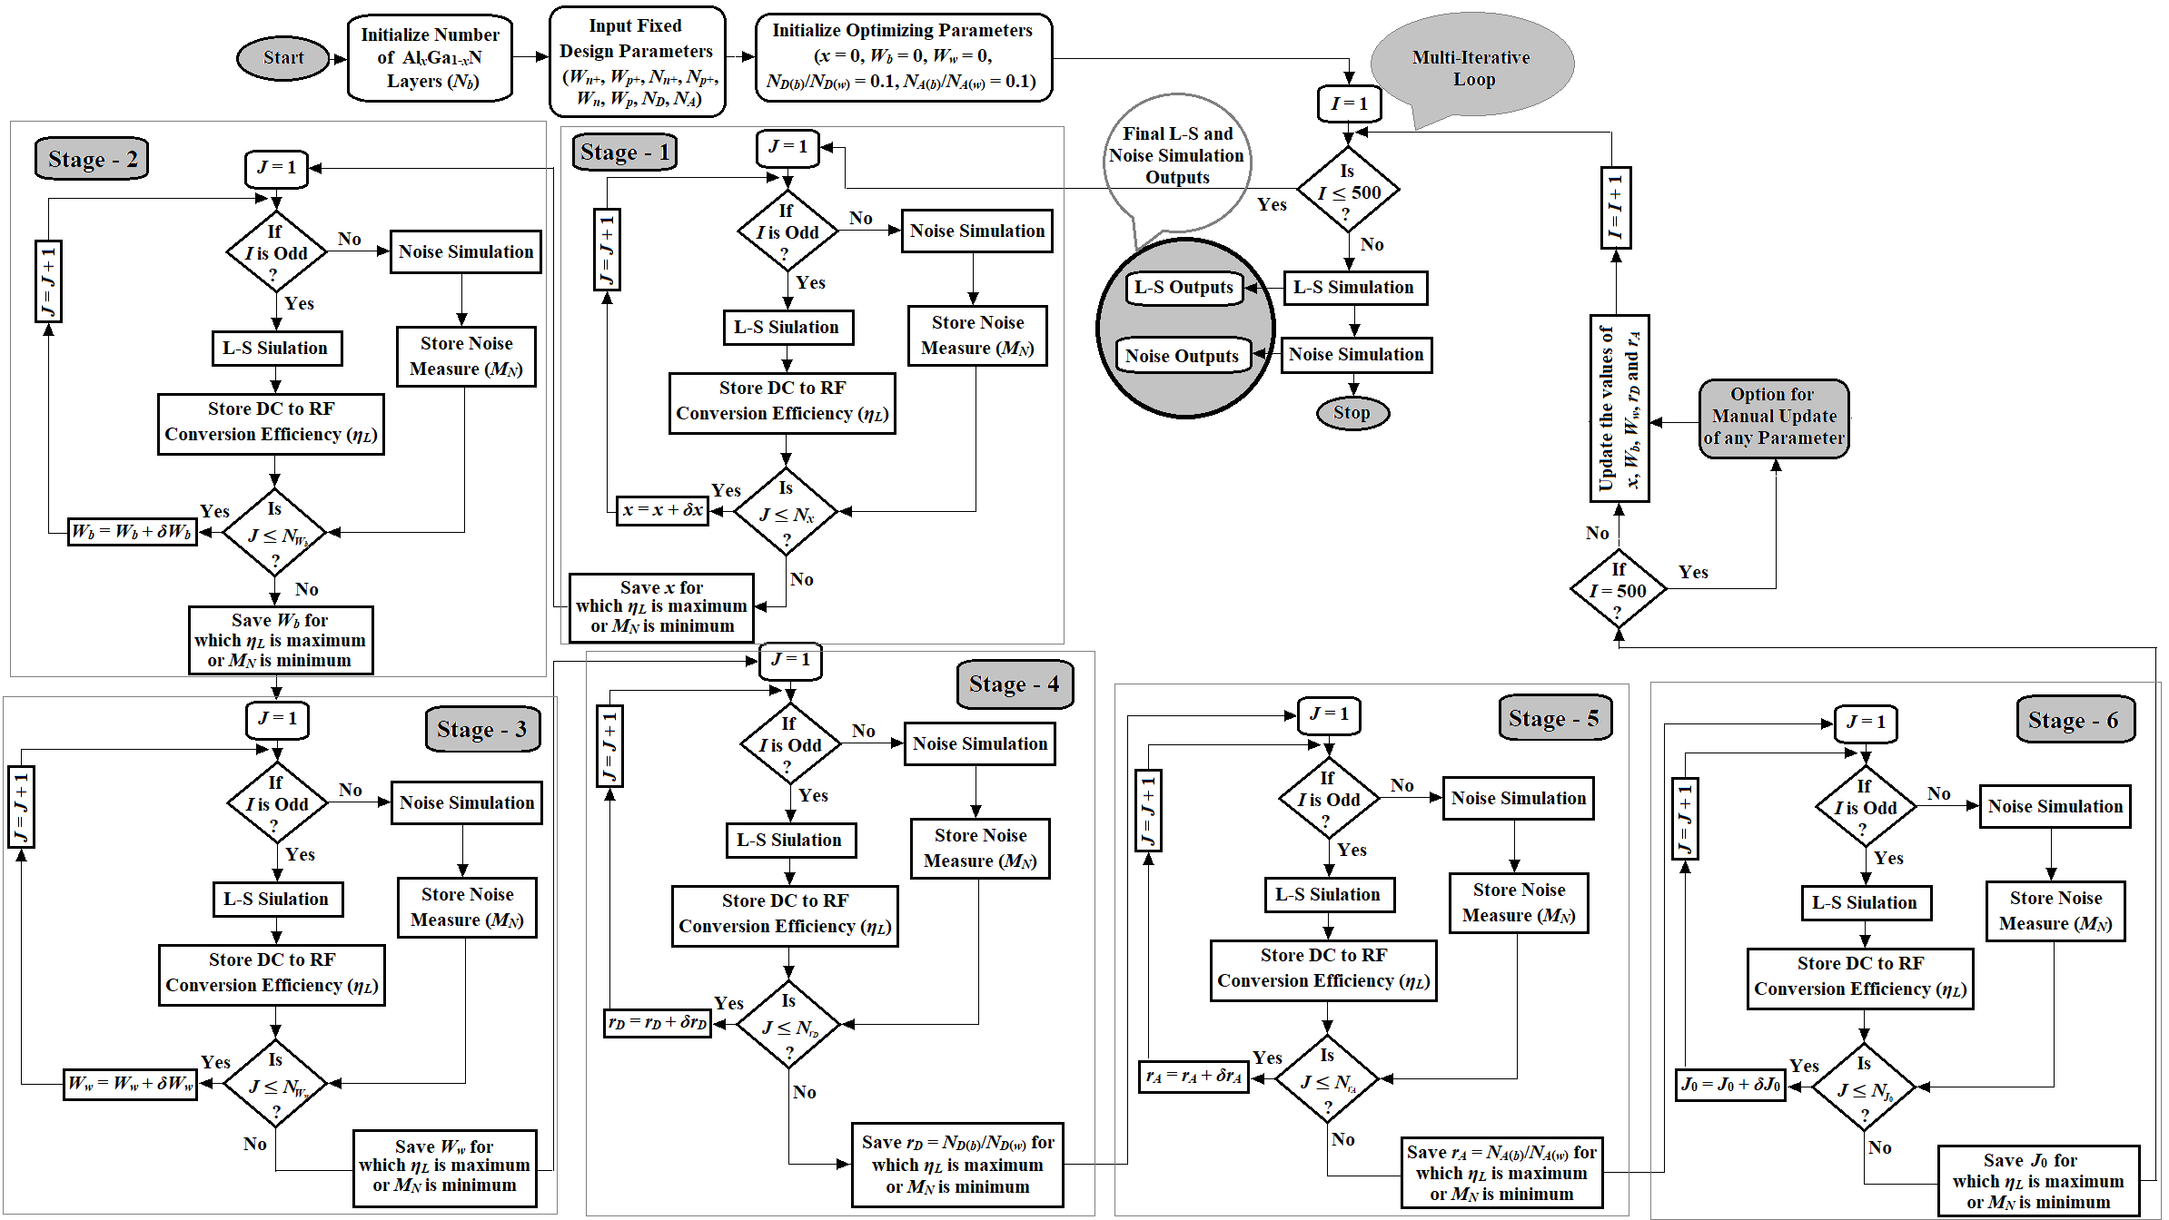
Fig. 2 Flowchart of the proposed MSMIO algorithm.

3. Optimization Technique
The design parameters like thickness of n- and p-epitaxial layers (W_{n} and W_{p}), n⁺- and p⁺-contact layers (W_{n+} and W_{p+}) and corresponding doping densities (i.e. N_{D}, N_{A}, N_{n+} and N_{p+} respectively) of 1.0 THz DDR are initially chosen by following the transit time technique adopted by Sze et al. [15] and optimized by using the non-sinusoidal voltage excited (NSVE) large-signal simulation method proposed by Acharyya et al. [16]. However, some important parameters related to the MQW structure are optimized by using the proposed MSMIO algorithm; those parameters are mole fraction (x) of Al in Al_{x}Ga_{1-x}N, thickness of Al_{x}Ga_{1-x}N layers (W_{b}), thickness of GaN layers (W_{w}), ratio of the doping concentration of Al_{x}Ga_{1-x}N layers (N_{D(b)} for n-side and N_{A(b)} for p-side) to the doping concentration of GaN layers (N_{D(w)} for n-side and N_{A(w)} for p-side), i.e. r_{D} = N_{D(b)}/N_{D(w)} for n-side and r_{A} = N_{A(b)}/N_{A(w)} for p-side (here the doping concentration of GaN layers inside the MQW structure are kept same as those of epitaxial doping concentrations, i.e. N_{D(w)} = N_{D} and N_{A(w)} = N_{A}) and bias current density (J₀). Therefore, the above-mentioned six parameters such as x, W_{b}, W_{w}, r_{D}, r_{A} and J₀ are optimized by using MSMIO algorithm subject to obtain maximum DC to RF conversion efficiency (η_{L}) and minimum noise measure (M_{N}) at the design frequency f_{d} = 1.0 THz.
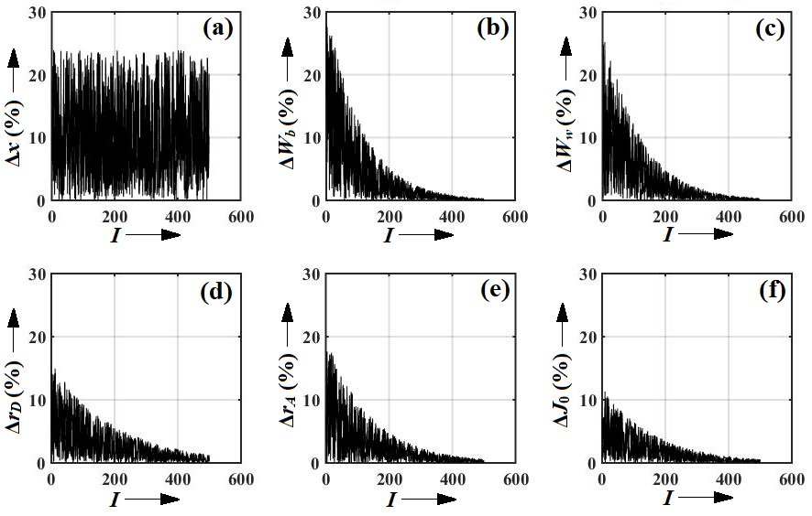
Fig. 3 The percentage of change in optimizing parameters in the present iteration with respect to the earlier iteration versus number of iterations plots.

The flowchart of the MSMIO algorithm is shown in Fig. 2. At the beginning, number of Al_{x}Ga_{1-x}N layers (N_{b}), fixed design parameters (W_{n}, W_{p}, W_{n+}, W_{p+}, N_{D}, N_{A}, N_{n+} and N_{p+}) and optimizing parameters (x, W_{b}, W_{w}, r_{D}, r_{A} and J₀) are initialized. The value of x is initialized to be x = 0, and it is increased up to x = 0.6; the value of x is not increased beyond 0.6 in order to avoid crystal mismatch between Al_{x}Ga_{1-x}N and GaN and trap states at Al_{x}Ga_{1-x}N/GaN interfaces. In the first stage, during the odd numbered iterations (i.e. I = 1, 3, 5, 7, …..), x is varied from x = 0 to x = 0.6 with the incremental step of δx = 0.01 subject to obtain the best value of x for which η_{L} is highest. However, in the same stage, the best value of x is obtained (0 ≤ x ≤ 0.6) subject to obtain minimum M_{N}, during the even numbered iterations (i.e. I = 2, 4, 6, 8, …..). Under a particular iteration, the best value of x obtained from stage – 1 is saved and forwarded to the stage – 2 in which the value of W_{b} is optimized by using the same method as in stage – 1, but considering the updated value of x obtained as the output of stage – 1 during the same iteration. Similarly, under a particular iteration, updated values of x and W_{b} obtained as the outcomes of stage – 1 and stage – 2 are used in simulations carried out in stage – 3 and so on. In the similar way, all the optimized values of x, W_{b}, W_{w}, r_{D}, r_{A} and J₀ are obtained within a particular iteration. During odd numbered iterations, the above parameters ate optimized subject to obtain maximum η_{L} by using NSVE large-signal simulation [16] and during even numbered iterations those are optimized subject to obtain minimum M_{N} by using small-signal noise simulation [9]. Total I = 500 iterations have to be repeated in order to achieve the convergence of all the stages from stage – 1 to stage – 6. However, the convergence of each stage is not guaranteed. The percentage of change in a parameter in the present iteration with respect to the earlier iteration (ΔК = [(К_{I} – К_{I-1})/ К_{I-1}]×100%, 1 < I ≤ 500); where К ϵ {x, W_{b}, W_{w}, r_{D}, r_{A}, J₀}) versus number of iteration (I) plots for all optimizing parameters are shown in Figs. 3 (a) – (f) for N_{b} = 10. It is observed that the only parameter x is not converging and maintaining its oscillatory nature up to the final iteration. However, all other parameters are found to be converged after 400 – 450 iterations. The optimum value of x is chosen by taking average of x values obtained by last 100 – 150 iterations. That is why, manual update option is kept after the final iteration (I = 500). The optimized x, W_{b}, W_{w}, r_{D}, r_{A} and J₀ are listed is Table 1. After completion of 500 iterations, final large-signal and noise characteristics of optimized Al_{x}Ga_{1-x}N/GaN heterostructure based MQW DDR diode designed to operate at 1.0 THz.

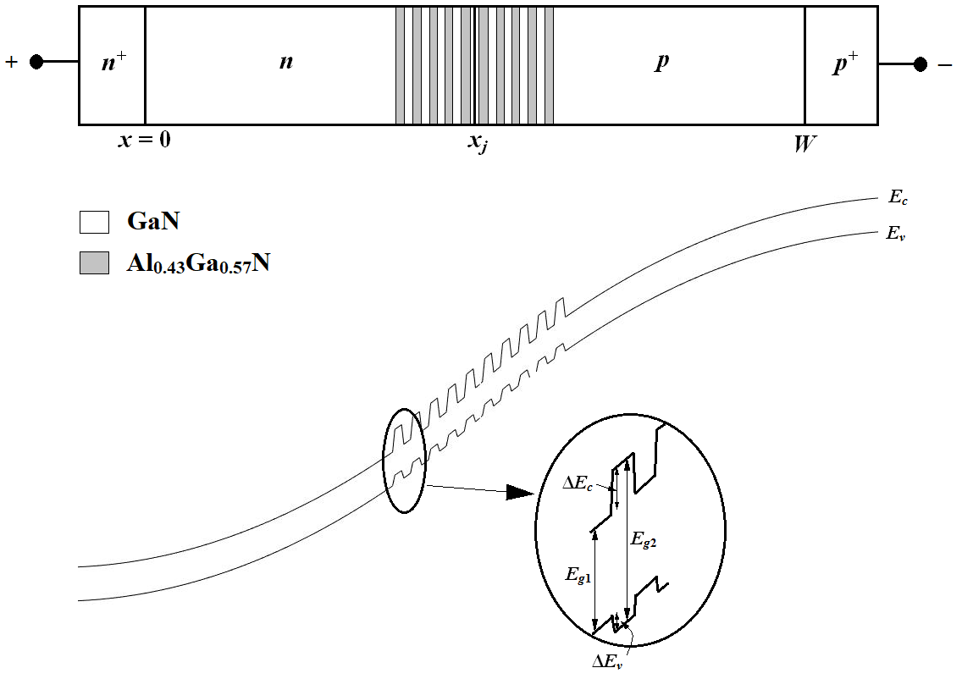
Fig. 4 1-D structure and associated energy-band diagram of the reverse biased optimized Al_{0.43}Ga_{0.57}N/GaN MQW DDR IMPATT diode.

4. Band Structure
It is observed that the MSMIO algorithm unable to take decision over the most favourable value of x subject to obtain highest η_{L} and lowest M_{N}; the algorithm does not converges in this case and remains oscillatory around the mean value of x = 0.43 and as a result of that this mean value is considered as the most favourable value of x for the purpose under consideration. Moreover, it is observed from the large-signal and noise simulations that although the power output and efficiency of the source monotonically increases with the increase of the number of Al_{0.43}Ga_{0.57}N layers (N_{b}), the noise performance of the source starts to deteriorate sharply when N_{b} is increased beyond N_{b} = 10; therefore, in the optimized device structure, the value of N_{b} is taken to be N_{b} = 10. The band diagram of the optimized Al_{0.43}Ga_{0.57}N/GaN heterostructure based 35 V diode is illustrated in Fig. 4. The electron affinity of GaN and Al_{0.43}Ga_{0.57}N are χ₁ = 4.10 eV and χ₂ = 2.59 eV respectively at 300 K [17]. Thus the conduction band and valence band discontinuities are given by ΔE_{c} = |χ₁ – χ₂| = 1.51 eV and ΔE_{v} = (ΔE_{g} – ΔE_{c}) = 1.30 eV respectively, where ΔE_{g} = |E_{g1} – E_{g2}|; E_{g1} = 3.39 eV and E_{g2} = 6.20 eV are the bandgaps of GaN and Al_{0.43}Ga_{0.57}N at 300 K respectively [17]. Thus in Al_{0.43}Ga_{0.57}N/GaN heterojunction, ΔE_{c} is found to be larger than ΔE_{v}. In the MQW structure, the Al_{0.43}Ga_{0.57}N/GaN junctions are found to be type-II heterojunctions (Staggered Gap).

5. Large-Signal and Noise Characteristics
The variations of RF power output (P_{RF}), DC to RF conversion efficiency (η_{L}) and noise measure (M_{N}) of optimized Al_{0.43}Ga_{0.57}N/GaN MQW IMPATTs with the number of Al_{0.43}Ga_{0.57}N layers (N_{b}) have been shown in Fig. 5. In is observed that the both the power output and conversion efficiency of the source increases with the increase of N_{b} from 0 to 16; whereas noise measure of the source decreases initially with the increase of N_{b} up to N_{b} = 10, attains its minimum value for N_{b} = 10, and finally sharply increases when N_{b} is increases beyond N_{b} = 10.
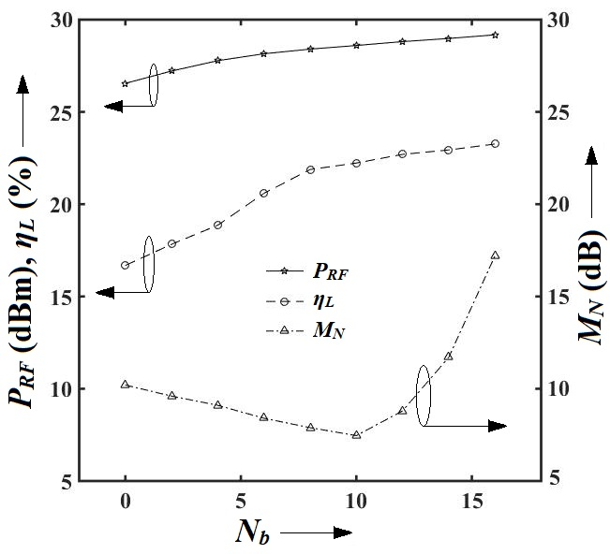
Fig. 5 RF power output, DC to RF conversion efficiency and noise measure versus number of Al_{0.43}Ga_{0.57}N layers in MQW structure.
Insertion of the higher bandgap material Al_{0.43}Ga_{0.57}N in the GaN DDR structure, in order to form MQW DDR structure influences the carrier transport properties of the system; especially saturation drift velocity, mobility, ionization rate of both electrons and holes get modified in the MQW structures as compared to the bulk GaN. Especially the reduction in the ionization rates with the increase of N_{b} in the MQW structure causes increase in both breakdown voltage and magnitude of negative conductance of the DDRs; which, in turn, results improvement in both power output and conversion efficiency of the source. However, quantum confinement of electrons and holes within the bound states in of MQWs associated with conduction and valence bands respectively near the high field region of the device, i.e. around the p-n junction causes localization of the impact ionization phenomena and thereby causes narrowing down of the charge multiplication region or avalanche zone; this is the cause of reduction of avalanche noise due to the insertion of Al_{0.43}Ga_{0.57}N layers in the DDR structure. However, the Al_{0.43}Ga_{0.57}N layers nearer to the p-n junction are only responsible of narrowing down of the avalanche zone, while those far away from the p-n junction, i.e. within the drift region do not influence the modulation of avalanche zone. Therefore, extra amount of Al_{0.43}Ga_{0.57}N layers does not have any significant for reducing the noise spectral density of the source; however those are responsible for reduction in the magnitude of negative resistance of the device. Therefore, extra amount of Al_{0.43}Ga_{0.57}N layers (N_{b} > 10) does not cause any change in the noise spectral density, but it causes decrement in the magnitude of negative resistance; and this is the cause of sharp increase of noise measure and consequent deterioration in the noise performance of the source for N_{b} > 10.
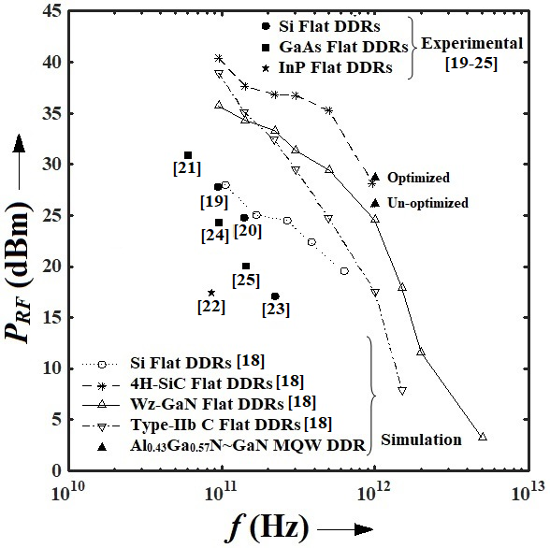
Fig. 6 RF power output versus frequency plots of different IMPATT sources.
Variations of power output and noise measure of homojunction flat DDR IMPATT sources based on different narrow and wide bandgap semiconductor materials with operating frequency have been shown in Figs. 6 and 7 respectively [18-26]; these are obtained from large-signal simulation and experimental measurements reported earlier [18-26]. The said figures also shows the power output and noise measure of optimized Al_{0.43}Ga_{0.57}N/GaN MQW IMPATT source designed to operate at 1.0 THz. It can be observed from those figures that the optimized MQW DDR IMPATT source is capable of delivering RF power of 29.56 dBm with noise measure of 7.46 dB. The power delivery capability of this optimized source is highest among all the sources under comparison; even it excels its nearest competitor 4H-SiC flat DDR source (P_{RF} = 28.36 dBm). More importantly, the noise performance of the optimized source is significantly better than its nearest candidate Wz-GaN flat DDR IMPATT source (M_{N} = 12.56 dB). However, it is interesting to observe from Figs. 7 and 6 that the un-optimized MQW DDR IMPATT source is capable of delivering RF power of 26.20 dBm with noise measure of 9.52 dB. Therefore, optimization of MQW structure by using MSMIO algorithm provided 116.77% increased power delivery capability where as the noise performance of the source improved by 37.77% reduction in noise measure.
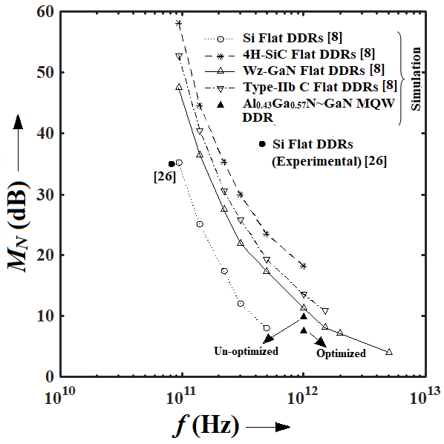
Fig. 7 Noise measure versus frequency plots of different IMPATT sources.

6. Fabrication Steps
The possible fabrication steps of MQW DDR IMPATT structure based on AlGaN/GaN material system have been discussed in this section. Initially, the n-buffer layer of 30 – 50 μm thickness having n-type doping concentration of 10²⁴ m⁻³ followed by n⁺-contact layer of 300 nm thickness and n-type doping concentration of 2×10²⁴ m⁻³ can be grown on single crytal c-plane (1000) sapphire (Al₂O₃) substrate by using metalorganic chemical vapor deposition (MOCVD) technique [12, 13]. The growth chamber pressure must be fixed at nearly 380 – 400 Torr and approximately 1220⁰ C temperature must be maintained inside of it. The most suitable sources of gallium (Ga) and nitrogen (N) are gaseous-phase trimythyl gallium (TMG) and ammonia (NH₃), respectively [12]. Controlled doses of donor impurity Si in the form of SiH₄ can be injected in the reaction chamber in order to achieve desired levels of doping concentrations in n⁺-layer and n-buffer layer [12]. The source of aluminium can be chosen to be trimethylaluminium (TMAl) during the growth of AlGaN/GaN MQW structure [ ]. Total ten periodes of Al_{0.43}Ga_{0.57}N (4.15 nm)/GaN (4.20 nm) can be grown by using MOCVD in order to achieve the optimized structure as discussed earlier in this chapter. The magnesium (Mg) impurities of appropriate dose can be introduced into the reaction chamber in form of bicyclopentadicnylmagnesium (Cp₂ Mg) during the growth of p- and p⁺-layers of the DDR structure. Diode mesas can be formed by using reactive-ion-etching (RIE) technique [28]. Suitable photolithographic steps can be used to expose p⁺-GaN and n⁺-GaN layers for subsequent metal depositions. Appropriate annealing steps must be followed in air, nitrogen, and oxygen ambient conditions at different annealing temperatures ranging from 350 to 650⁰ C after Ni (20 nm)/Au (150 nm) and Ti (30 nm)/Al (100 nm)/Ti (20 nm)/Au (150 nm) depositions on p⁺-GaN and n⁺-GaN layers, respectively [29, 30].

7. Conclusions
In this chapter, a newly developed MSMIO algorithm has been described for optimizing the design parameters of THz MQW DDR IMPATT diode oscillators. The MQW DDR IMPATT source based on Al_{0.43}Ga_{0.57}N/GaN heterostructures designed to operate at 1.0 THz has been considered for this purpose of investigation. The optimization has been carried out subject to achieve favourable large-signal as well as avalanche noise characteristics of the source at 1.0 THz. The large-signal and noise characteristics of optimized as well as un-optimized MQW DDR structures are compared in order to verify the proficiency of the proposed algorithm; results are compared with simulation and experimental results of 1.0 THz oscillators based on other semiconductor materials reported earlier.

References
- A. Acharyya and J. P. Banerjee, “Prospects of IMPATT Devices based on Wide Bandgap Semiconductors as Potential Terahertz Sources,” Applied Nanoscience, vol. 4, pp. 1-14, 2014.
- A. Biswas, S. Sinha, A. Acharyya, A. Banerjee, S. Pal, H. Satoh and H. Inokawa, “1.0 THz GaN IMPATT Source: Effect of Parasitic Series Resistance,” Journal of Infrared, Millimeter and Terahertz Waves, vol. 39, issue 10, pp. 954-974, 2018.
- A. Acharyya, J. Goswami, S. Banerjee and J. P. Banerjee, “Quantum Corrected Drift-Diffusion Model for Terahertz IMPATTs Based on Different Semiconductors,” Journal of Computational Electronics, vol. 14, pp. 309-320, 2015.
- A. Acharyya, A. Mallik, D. Banerjee, S. Ganguli, A. Das, S. Dasgupta and J. P. Banerjee, “IMPATT Devices Based on Group III-V Compound Semiconductors: Prospects as Potential Terahertz Radiators,” HKIE Transactions, vol. 21, issue 3, pp. 135-147, 2014.
- A. Acharyya, S. Banerjee and J. P. Banerjee, “Potentiality of Semiconducting Diamond as Base Material of Millimeter-Wave and Terahertz IMPATT Devices,” Journal of Semiconductors, vol. 35, no. 3, pp. 034005-1-11, 2013.
- A. Acharyya, K. Datta, R. Ghosh, M. Sarkar, R. Sanyal, S. Banerjee and J. P. Banerjee, “Diamond Based DDR IMPATTs: Prospects and Potentiality as Millimeter-Wave Source at 94 GHz Atmospheric Window,” Radioengineering, vol. 22, no. 2, pp. 624-631, 2013.
- A Acharyya and J. P. Banerjee, “Potentiality of IMPATT Devices as Terahertz Source: An Avalanche Response Time Based Approach to Determine the Upper Cut-off Frequency Limits,” IETE Journal of Research, vol. 59, issue 2, pp. 118-127, March-April 2013.
- P. K. Bandyopadhyay, A. Biswas, A.K. Bhattacharjee and A. Acharyya, “Millimeter-Wave and Terahertz IMPATT Sources: Influence of Inter-Carrier Interactions,” International Journal of Nanoparticles, vol. 10, nos. 1/2, pp. 124-140, 2018.
- M. Ghosh, S. Ghosh, P. K. Bandyopadhyay, A. Biswas, A.K. Bhattacharjee and A. Acharyya, “Noise Performance of 94 GHz Multiple Quantum Well Double-Drift Region IMPATT Sources,” Journal of Active and Passive Electronic Devices, vol. 13, issue 2/3, pp. 195-207, 2018.
- S. Banerjee, A. Acharyya and J. P. Banerjee, “Noise Performance of Heterojunction DDR MITATT Devices Based on Si~Si_{1-x}Ge_{x} at W-Band,” Active and Passive Electronic Components, vol. 2013, pp. 1-7, 2013.
- M. Ghosh, S. Ghosh and A. Acharyya, “Self-Consistent Quantum Drift-Diffusion Model for Multiple Quantum Well IMPATT Diodes,” Journal of Computational Electronics, vol. 15, issue 4, pp. 1370-1387, 2017.
- V. A. Dmitriev et al., “SiC a(3)n alloys and wide band gap nitrides grown on SiC substrates,” Inst Phys Conf. Ser., vol. 141, pp. 497–502, 1995.
- Y. V. Melnik, I. P. Nikitina, A. S. Zubrilov, A. A. Sitnikova , Y. G. Musikhin, V. A. Dmitriev, “High-quality GaN grown directly on SiC by halide vapour phase epitaxy,” Inst Phys. Conf. Ser., vol. 142, pp. 863–866, 1996.
- A. Biswas, S. Sinha, A. Acharyya, A. Banerjee, S. Pal, H. Satoh and H. Inokawa, “1.0 THz GaN IMPATT Source: Effect of Parasitic Series Resistance,” Journal of Infrared, Millimeter and Terahertz Waves, vol. 39, issue 10, pp. 954-974, 2018.
- S. M. Sze, and R. M. Ryder, “Microwave Avalanche Diodes,” Proc. of IEEE, Special Issue on Microwave Semiconductor Devices, vol. 59, pp. 1140–1154, 1971.
- A. Acharyya, S. Banerjee and J. P. Banerjee, “Effect of Junction Temperature on the Large-Signal Properties of a 94 GHz Silicon Based Double-Drift Region Impact Avalanche Transit Time Device,” Journal of Semiconductors, vol. 34, issue 2, pp. 024001-12, 2013.
- ________________________, “Electronic Archive: New Semiconductor Materials, Characteristics and Properties,” Available from: http://www.ioffe.ru/SVA/NSM/Semicond/index.html (Last accessed on: June 2019).
- A. Acharyya, “RF Performance of IMPATT Sources and Their Optical Control,” Lambert Academic Publishing, Germany, 2015, ISBN: 978-3-659-68422-7.
- J. F. Luy, A. Casel, W. Behr and E. Kasper, A 90-GHz double-drift IMPATT diode made with Si MBE, IEEE Trans. Electron Devices 34, 1084-1089 (1987).
- M. Wollitzer, J. Buchler, F. Schafflr and J. F. Luy, “D-band Si-IMPATT diodes with 300 mW CW output power at 140 GHz,” Electronic Letters, vol. 32, pp. 122-123, 1996.
- H. Eisele, “Selective etching technology for 94 GHz, GaAs IMPATT diodes on diamond heat sinks,” Solid State Electronics, vol. 32, no. 3, pp. 253-257, 1989.
- H. Eisele, C. C. Chen, G. O. Munns, G. I. Haddad, “The potential of InP IMPATT diodes as high-power millimetre-wave sources: first experimental results,” IEEE MTT-S Int. Microwave Symp. Digest, vol. 2, pp. 529-532, 1996.
- T. A. Midford, and R. L. Bernick, “Millimeter Wave CW IMPATT diodes and Oscillators,” IEEE Trans. Microwave Theory Tech., vol. 27, pp. 483-492, 1979.
- M. Tschernitz and J. Freyer, “140 GHz GaAs double-Read IMPATT diodes,” Electronic Letters, vol. 31, no. 7, no. 582-583, 1995.
- M. G. Adlerstein and S. L. G. Chu, “GaAs IMPATT diodes for 60 GHz,” IEEE Electron Devices Letter, vol. 5, pp. 97-97, 1984.
- H. Okamoto, and M. Ikeda, “A Comparative Study of Noise Properties of Si IMPATT Diodes Operating at 80 GHz,” Proceedings of IEEE (Lett.), vol. 64, pp. 367-368, 1976.
- T. N. Oder, J. Y. Lin, and H. X. Jiang, “Fabrication and optical studies of AlGaN/GaN quantum-well waveguides,” Applied Physics Letters, vol. 79, no. 1, pp. 12-14, 2001.
- Adesida et al., “Dry and wet etching for group III nitrides,” MRS Internet J. Nitride Semiconductor Res., vol. 4S1, pp. G1.4, 1999.
- C. F. Chu, C.C. Yu, Y.K. Wang, J.Y. Tsai, F.I. Lai and S.C. Wang, “Low-resistance ohmic contacts on p-type GaN using Ni/Pd/Au metallization,” Applied Physics Letters, vol. 77, pp. 3423–3425, 2000.
- J. Burm, K. Chu,W.A. Davis,W.J. Schaff, L.F. Eastman and T.J. Eustis, “Ultra-low resistive ohmic contacts on n-GaN using Si implantation,” Applied Physics Letters, vol. 70, pp. 464, 1997.

